Business Sequence Overview
Did you ever venture down the road to an unknown location, not sure where you are going with no address to plug into the GPS? How far would you go before you began to realize that you are lost? Who knows where you will end up!
I really don’t know anyone who would jump in their car and do that… but for some reason they will do it with their businesses. They will start a business and for years not be sure where they are going just hoping something good will come of it. As long as they are making money they guess it’s OK.
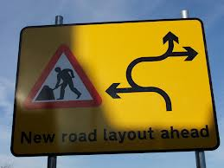
What we all need is a good sequenced business plan (model)… And like progaming your GPS, we need to start with the end in mind.
A Business Sequence Plan will often have 5 to 7 steps (stages or phases) to work through. As I said earlier as you begin to develop your plan you must start with the end in mind… that’s what we call your EXIT Plan or what you plan to do once you have built your market. For instance, you develop a business through private funding. Your EXIT plan is when you wish to go public with with an IPO, changing the structure from a pirvate organization to a public corporation or possibly sell as an acqusition or merger.
Here are a couple of graphics showing typical stages of business growth. You will notice that there is a general pattern for businesses. Once they reach maturity if we don’t have direction at that point we begin to lose steam and the business begins to wind down. A good serial entrepreneur knows not to go there. They will build the business up to maturity, build the business to have maximum value and then sell it and allow the new owner to continue running it giving them the freedom to build another business.
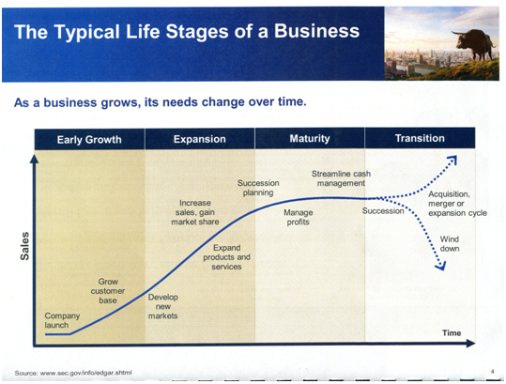
Another view of the same idea…
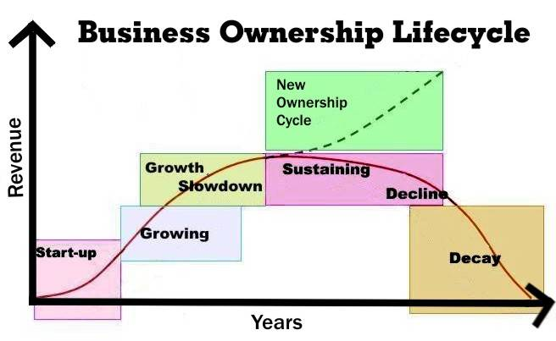
So, what do we do to take a business to maturity?
Below are the general formats for two types of sequencing that will assist in growing a business:
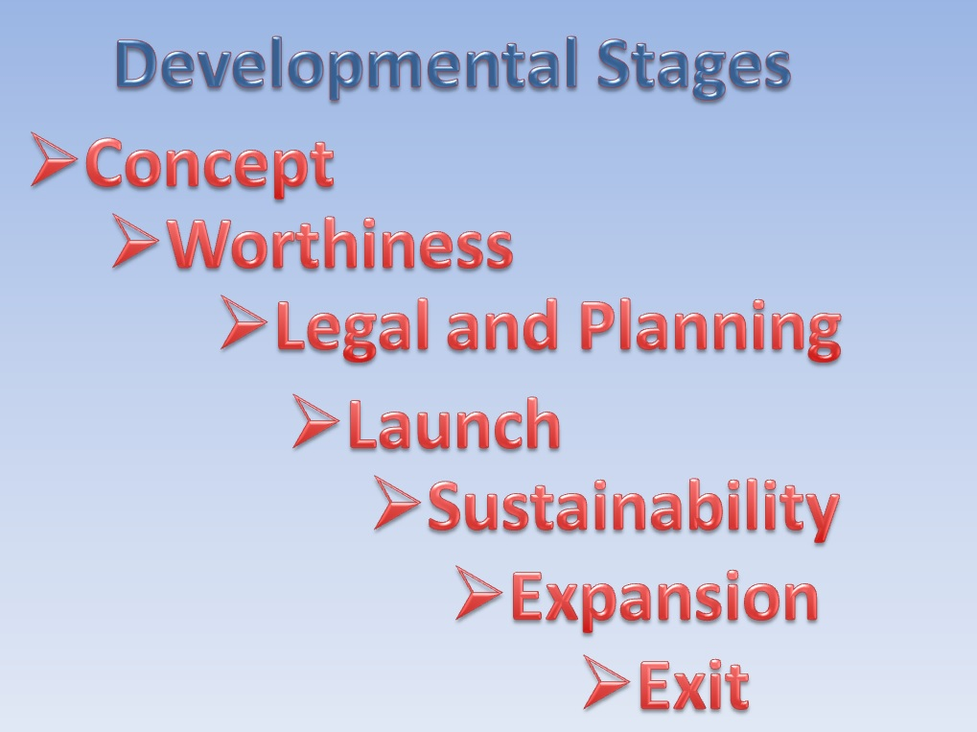
The following diagram is another format that may give you some guidance as you develop your own sequence. Once completed you should know what you need next in your process of growing your business.
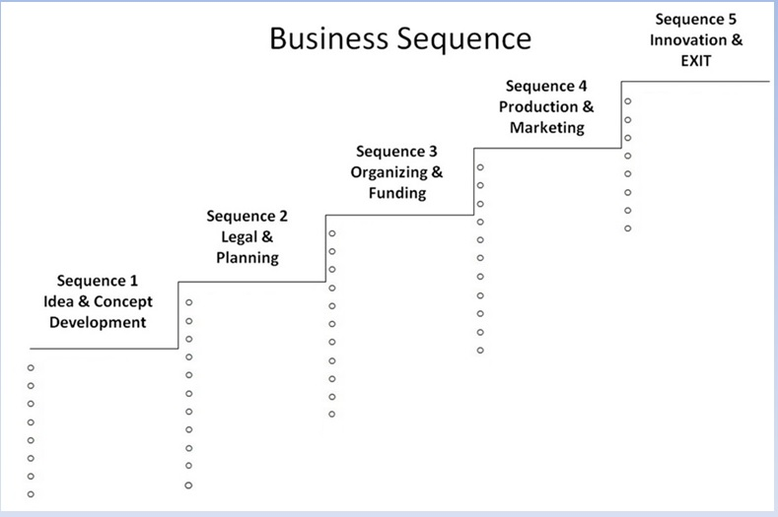

What I Can Do To Assist You
I generally work with the last process with the 5 sequences (stages or phases). I will work with you to begin by first defining your core values. This is the foundation upon which you will build your business. These are the fundamentals that you stand for and will not wavier. As you build you teams you will want to always reflect upon your values. You want people who share your same values. Next, we focus on what you wish to do as an EXIT Plan. This will help define the details you list in each of your steps(stages or phases) Below is a sample of what we will often place in sequence 1.
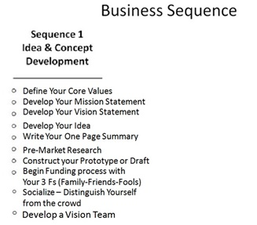
Each sequence has major processes that must be linked (not all) into the next sequence. The following graphics show you how we will often link a process that will change through each of your stages.
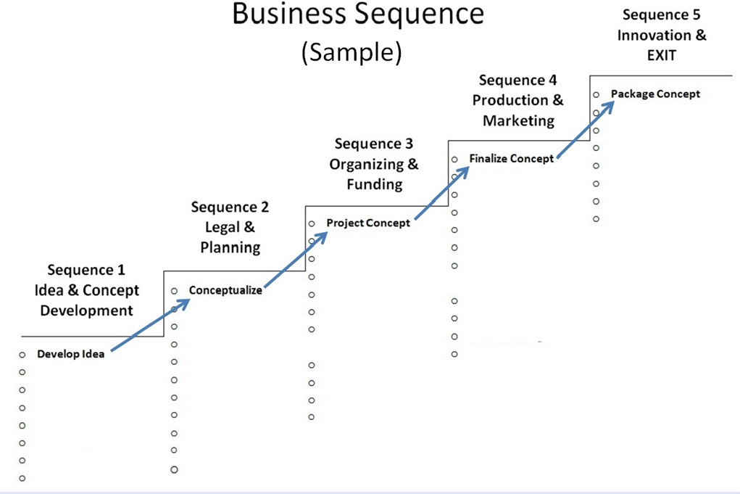
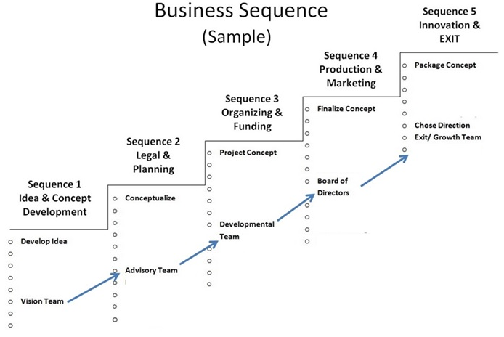

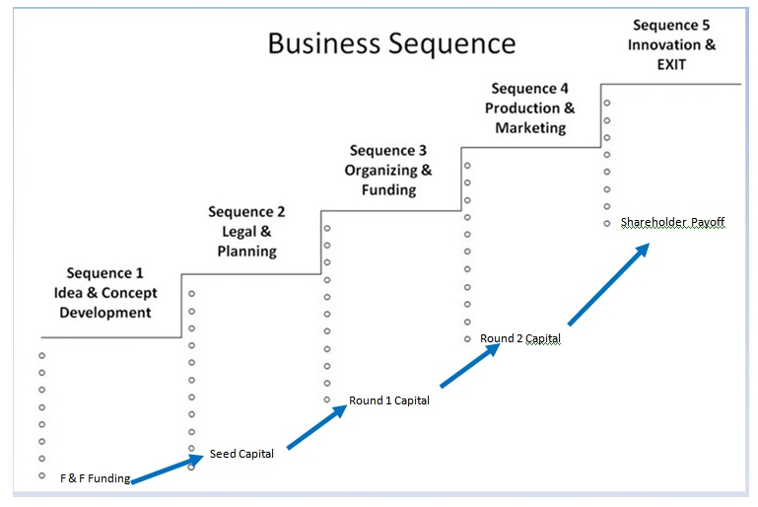
Any successful CEO will seek advisors, coaches, mentors who will assist them in staying focused and on track. They will not attempt to build this structure and follow it as a solo-entrepreneur.
This is where I can assist you in developing your own personal sequence plan and mentor you through the process.

How do you contract my services?
We have plans to fit every stage of your business and every budget, so contact us.
If you can see the need for sequencing your business growth
(and truthfully, every successful business does)
you can contact me via email
support@adamsbusinessdevelopment
or by phone for a
free initial consultation.
From there we can discuss the detail of how you wish to move forward.

